- From your Zoom home page click on your profile photo in the upper right hand corner.
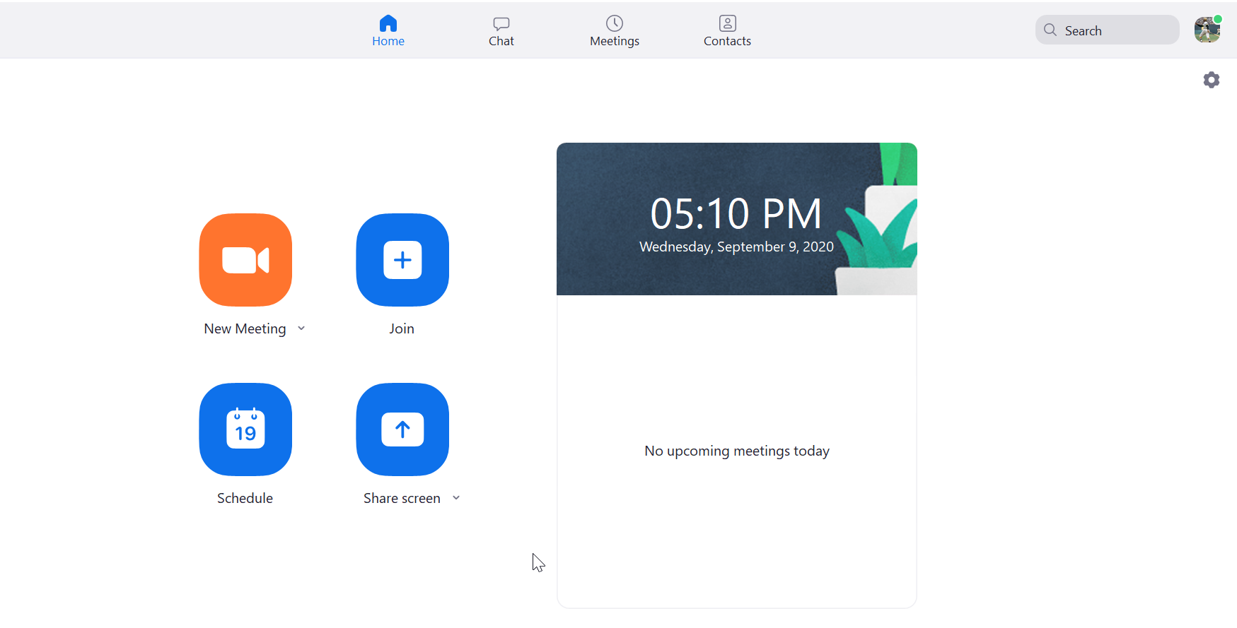
- From the menu click on “Check for updates”.
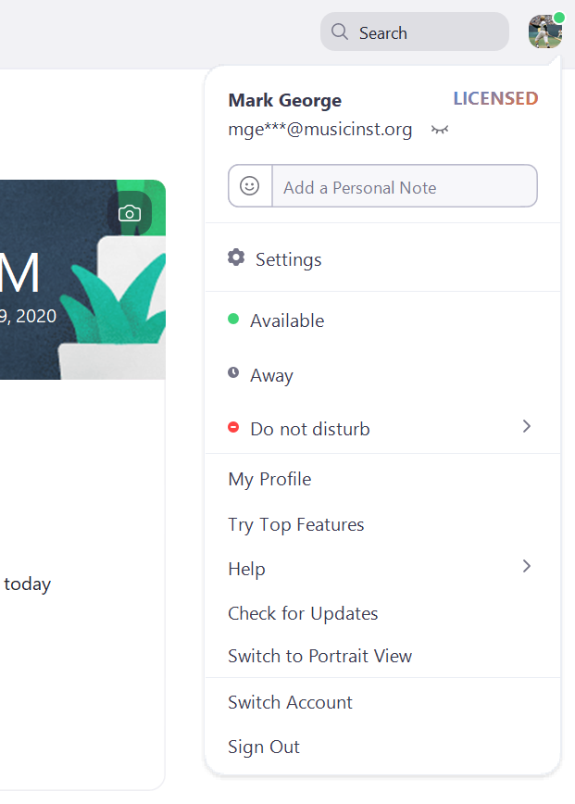
- Be sure you are using the latest version of Zoom “5.2.3” as of September 9th.
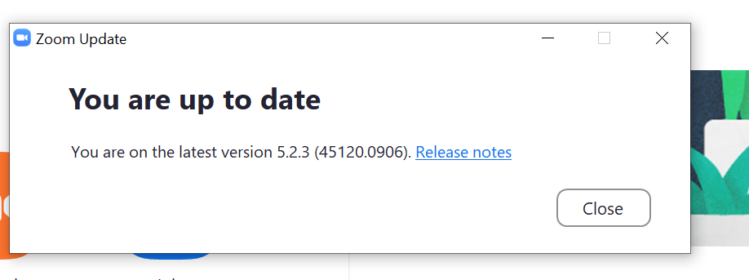
- Once the latest version is installed, open “settings” by clicking on the wheel icon.
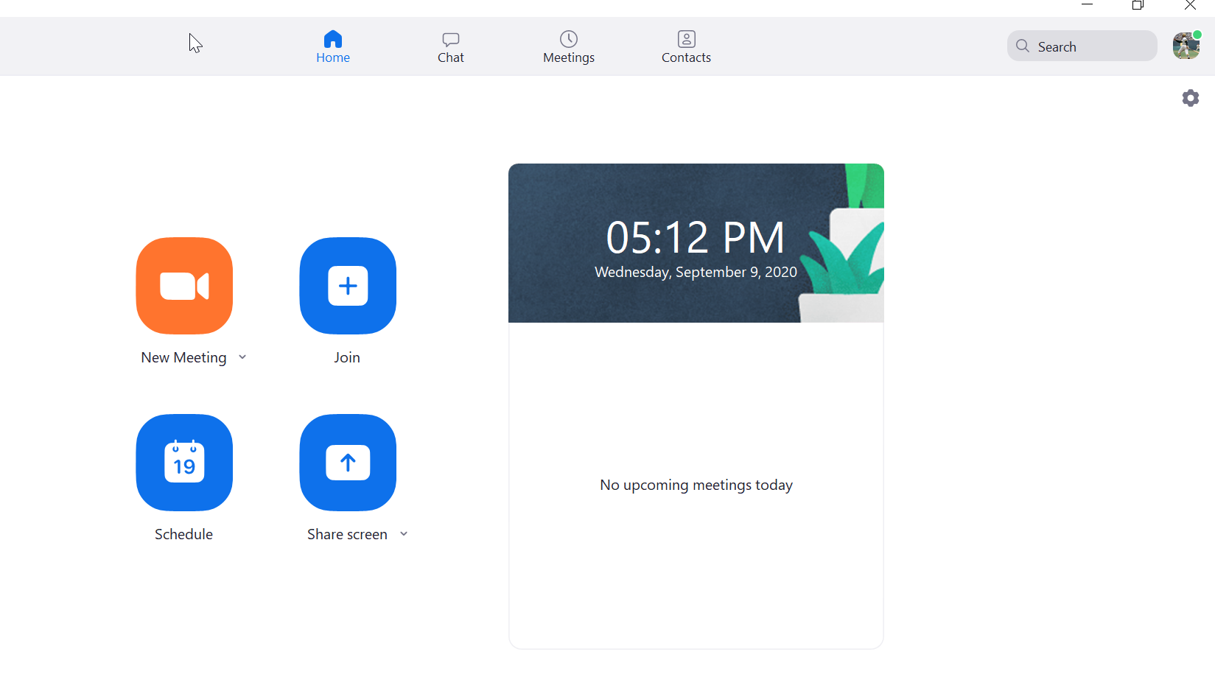
- Click on “Audio”
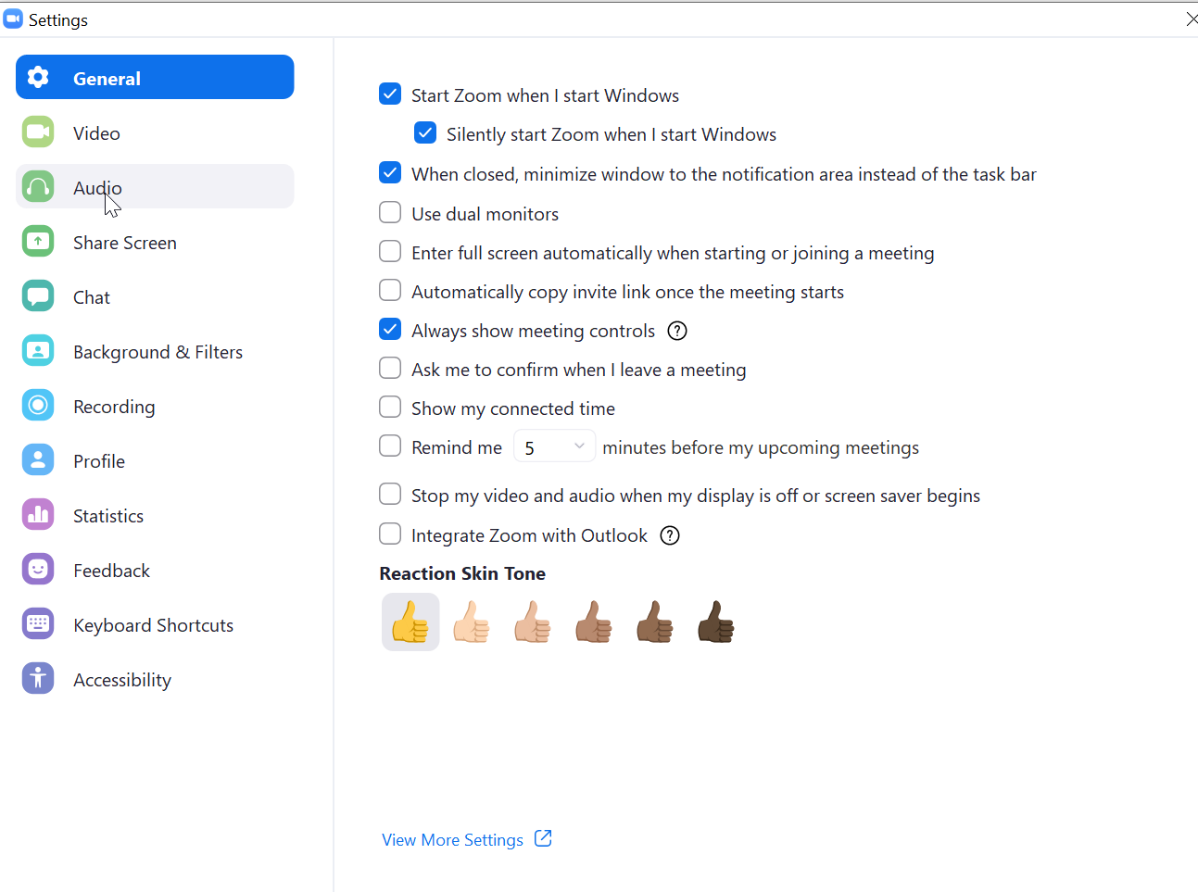
- Within audio settings, click on “Advanced”.
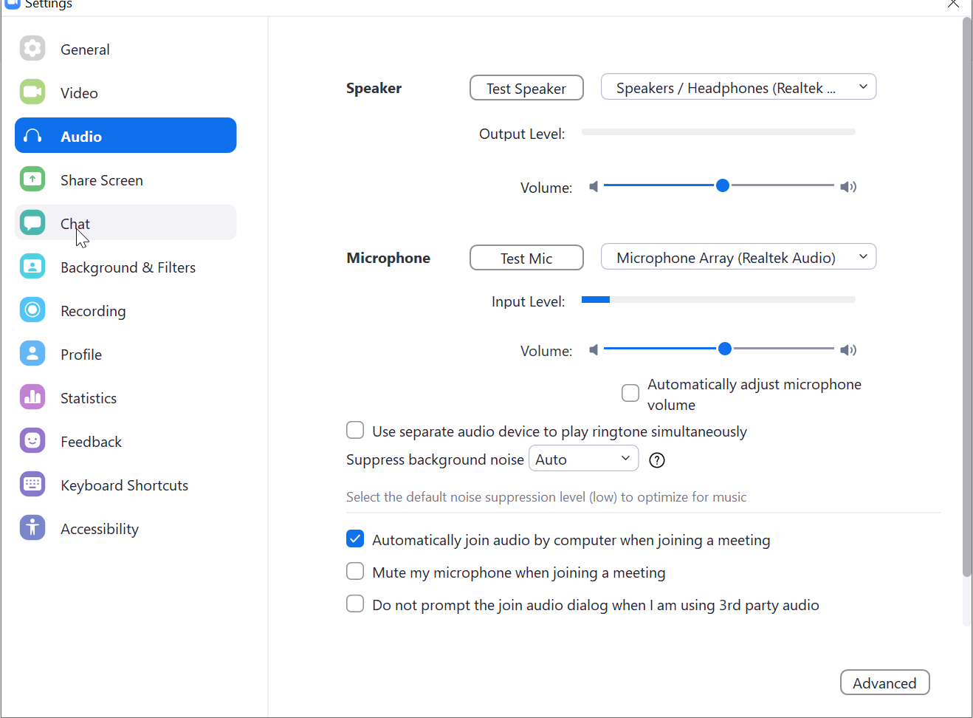
- Check the boxes for “Disable echo cancellation” and “High fidelity mode”.
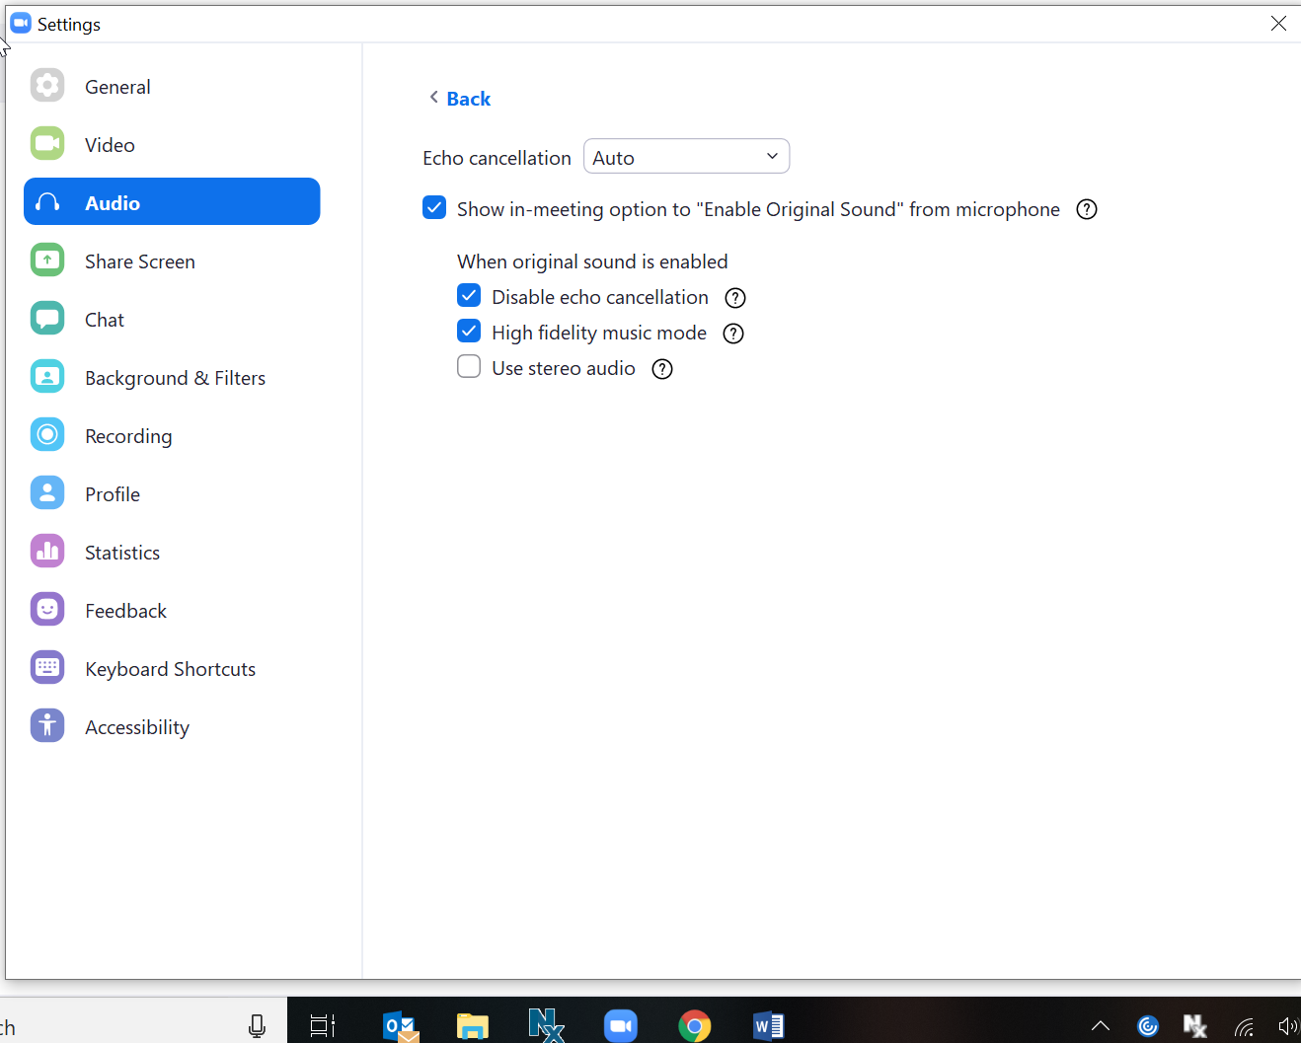
USB microphone suggestions
Blue Snowball USB Condenser Microphone ca. $49.00
Blue Yeti USB Microphone ca. $172.00
Shure MV51 USB Microphone ca. $199.00

Powerline Ethernet Adaptors
Netgear Powerline 1000 ca. $72.00
Netgear Powerline 2000 ca. $109.00

